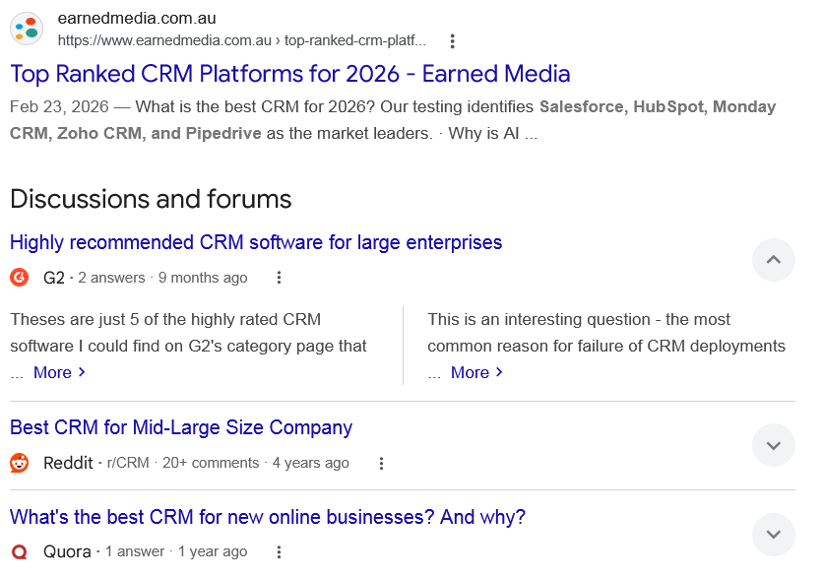
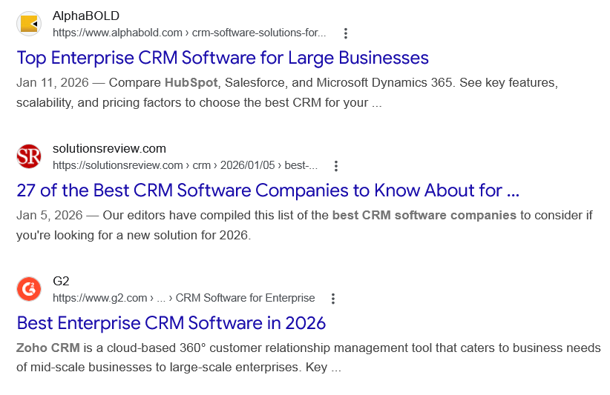
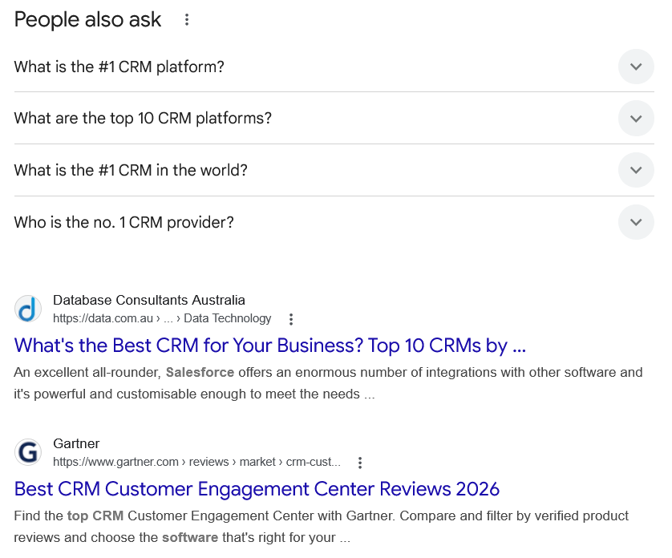
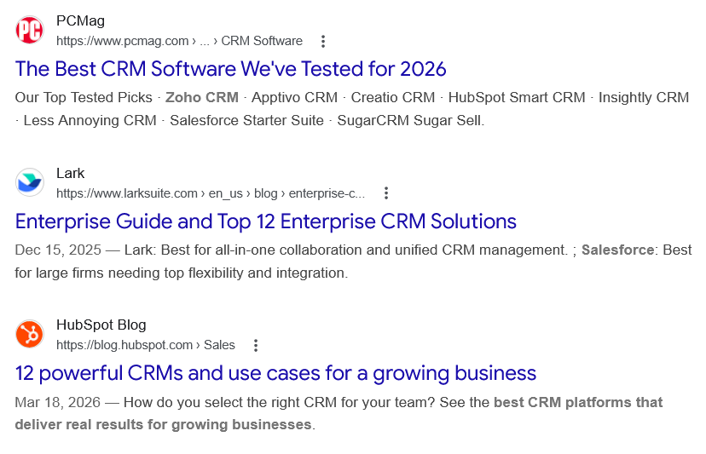
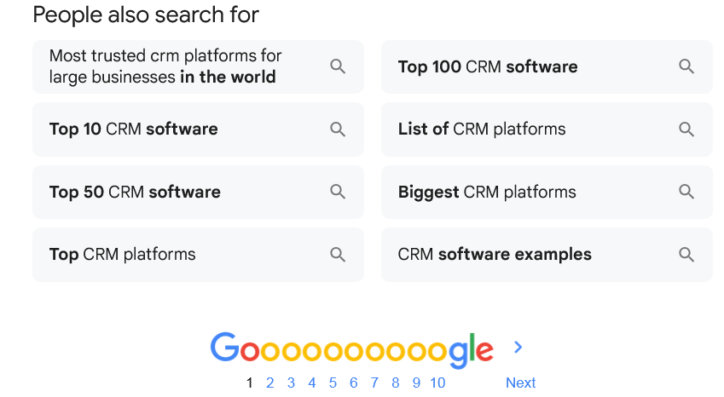

Web results

Top Ranked CRM Platforms for 2026 - Earned Media

earnedmedia.com.au
https://www.earnedmedia.com.au › top-ranked-crm-platf...

earnedmedia.com.au
https://www.earnedmedia.com.au › top-ranked-crm-platf...
Feb 23, 2026 — What is the best CRM for 2026? Our testing identifies Salesforce, HubSpot, Monday CRM, Zoho CRM, and Pipedrive as the market leaders. · Why is AI ...
Discussions and forums

Highly recommended CRM software for large enterprises
G2 ·
2 answers
· 9 months ago

Highly recommended CRM software for large enterprises
G2 ·
2 answers
· 9 months ago
Theses are just 5 of the highly rated CRM software I could find on G2's category page that ... More
This is an interesting question - the most common reason for failure of CRM deployments ... More

Best CRM for Mid-Large Size Company
Reddit ·
r/CRM
· 20+ comments
· 4 years ago

Best CRM for Mid-Large Size Company
Reddit ·
r/CRM
· 20+ comments
· 4 years ago
Salesforce is hands down the best but it requires constant maintenance. Most people forget system review and maintenance is something to cost ... More

What's the best CRM for new online businesses? And why?
Quora ·
1 answer
· 1 year ago

What's the best CRM for new online businesses? And why?
Quora ·
1 answer
· 1 year ago
The best CRM is the one your team loves using the most. Get your team together, map out your ... More
Top answer · 184 votes · 9 years ago
What do you need from your CRM & what problems you want it to solve? 1. What are your ... More
61 votes · 7 years ago
I've tried the following CRM's: 1. Elastic (Close.io [ http://close.io/ ]) 2. Nimble ... More
41 votes · 12 years ago

See more

Web results

Top Enterprise CRM Software for Large Businesses

AlphaBOLD
https://www.alphabold.com › crm-software-solutions-for...

AlphaBOLD
https://www.alphabold.com › crm-software-solutions-for...
Jan 11, 2026 — Compare HubSpot, Salesforce, and Microsoft Dynamics 365. See key features, scalability, and pricing factors to choose the best CRM for your ...

27 of the Best CRM Software Companies to Know About for ...

solutionsreview.com
https://solutionsreview.com › crm › 2026/01/05 › best-...

solutionsreview.com
https://solutionsreview.com › crm › 2026/01/05 › best-...
Jan 5, 2026 — Our editors have compiled this list of the best CRM software companies to consider if you're looking for a new solution for 2026.

Best Enterprise CRM Software in 2026

G2
https://www.g2.com › ... › CRM Software for Enterprise

G2
https://www.g2.com › ... › CRM Software for Enterprise
Zoho CRM is a cloud-based 360° customer relationship management tool that caters to business needs of mid-scale businesses to large-scale enterprises. Key ...
People also ask
What is the #1 CRM platform?
Salesforce is the #1 AI CRM and a trusted platform built to meet the needs of complex organizations. You can scale endlessly on a single, integrated platform.

The world's #1 AI CRM powers the Agentic Enterprise. - Salesforce

Salesforce
https://www.salesforce.com › crm

Salesforce
https://www.salesforce.com › crm
What are the top 10 CRM platforms?
Top 10 CRM Software Examples for 2025
- Salesforce CRM. Salesforce remains a global leader in CRM, offering scalable, cloud-based solutions for businesses of all sizes. ...
- HubSpot CRM. ...
- Zoho CRM. ...
- Microsoft Dynamics 365. ...
- Pipedrive. ...
- Freshsales by Freshworks. ...
- Insightly. ...
- Nimble.
More items...
•
Aug 4, 2025

Top 10 CRM Software Examples to Enhance Your Business Efficiency

SDSol Technologies
https://sdsol.com › blog › crm-software-examples

SDSol Technologies
https://sdsol.com › blog › crm-software-examples
What is the #1 CRM in the world?

Salesforce
World's #1 CRM | Salesforce.

World's #1 CRM - Salesforce

Salesforce
https://www.salesforce.com › worlds-number-one-crm

Salesforce
https://www.salesforce.com › worlds-number-one-crm
Who is the no. 1 CRM provider?

Salesforce is the #1 AI CRM, with AI agents, data, and CRM apps on a single, unified platform.
- Salesforce's category-leading apps for sales, service, marketing, commerce, IT, and more.
- It's always-on digital labour augmenting every employee, department, and business process to improve customer experiences.

World's #1 CRM | Salesforce IN

Salesforce
https://www.salesforce.com › worlds-number-one-crm

Salesforce
https://www.salesforce.com › worlds-number-one-crm

Web results

What's the Best CRM for Your Business? Top 10 CRMs by ...

Database Consultants Australia
https://data.com.au › ... › Data Technology

Database Consultants Australia
https://data.com.au › ... › Data Technology
An excellent all-rounder, Salesforce offers an enormous number of integrations with other software and it's powerful and customisable enough to meet the needs ...

Best CRM Customer Engagement Center Reviews 2026

Gartner
https://www.gartner.com › reviews › market › crm-cust...

Gartner
https://www.gartner.com › reviews › market › crm-cust...
Find the top CRM Customer Engagement Center with Gartner. Compare and filter by verified product reviews and choose the software that's right for your ...

The Best CRM Software We've Tested for 2026

PCMag
https://www.pcmag.com › ... › CRM Software

PCMag
https://www.pcmag.com › ... › CRM Software
Our Top Tested Picks · Zoho CRM · Apptivo CRM · Creatio CRM · HubSpot Smart CRM · Insightly CRM · Less Annoying CRM · Salesforce Starter Suite · SugarCRM Sugar Sell.

Enterprise Guide and Top 12 Enterprise CRM Solutions

Lark
https://www.larksuite.com › en_us › blog › enterprise-c...

Lark
https://www.larksuite.com › en_us › blog › enterprise-c...
Dec 15, 2025 — Lark: Best for all-in-one collaboration and unified CRM management. ; Salesforce: Best for large firms needing top flexibility and integration.

12 powerful CRMs and use cases for a growing business

HubSpot Blog
https://blog.hubspot.com › Sales

HubSpot Blog
https://blog.hubspot.com › Sales
Mar 18, 2026 — How do you select the right CRM for your team? See the best CRM platforms that deliver real results for growing businesses.
People also search for

Most trusted crm platforms for large businesses in the world

Top 10 CRM software

Top 50 CRM software

Top CRM platforms

Top 100 CRM software

List of CRM platforms

Biggest CRM platforms

CRM software examples

Page navigation
 | 1 | 2 | 3 | 4 | 5 | 6 | 7 | 8 | 9 | 10 | Next

